A000-Am, S-Colombia-Tairona-Tumbaga-Male leader seated with feather headdress-1000-1500 CE

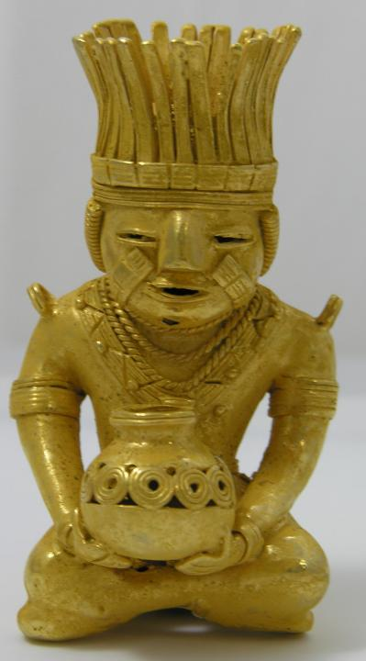

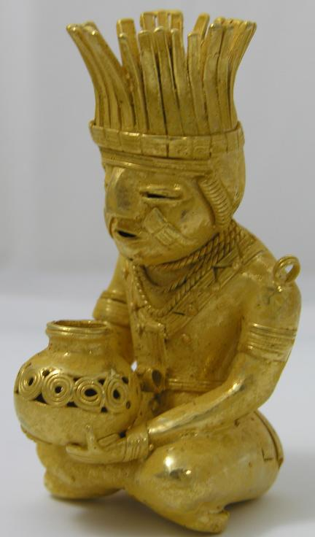 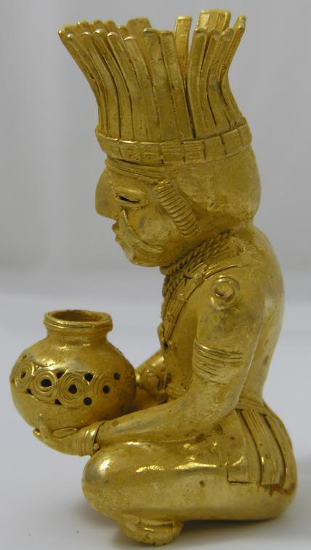 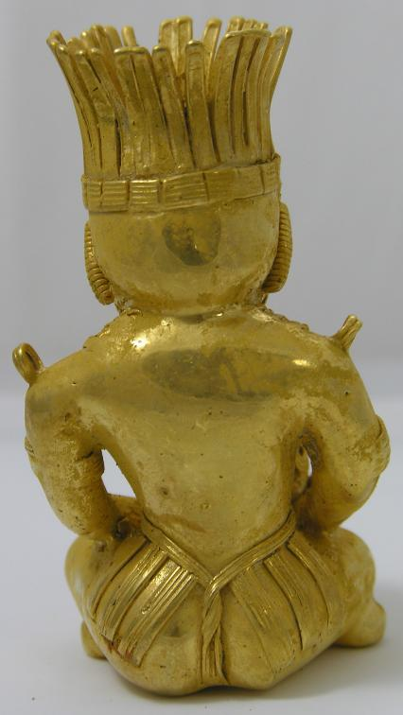 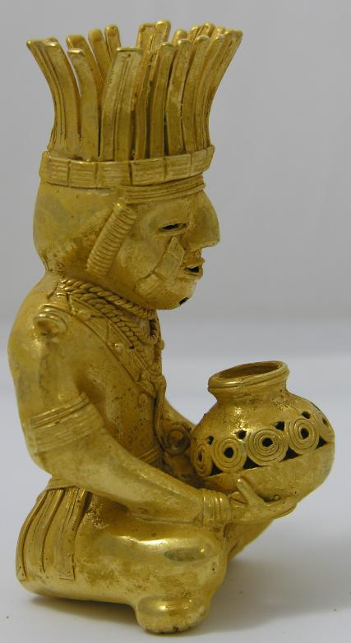

Figs. 1-6. Colombia-Tairona-Tumbaga-Male leader seated with feather headdress-1000-1500 CE

Case No.: 7

**Accession No.**

**Formal Label:** Colombia-Tairona-Tumbaga-Male leader seated with feather headdress-1000-1500 CE

**Display Description:**

Male leader seated with 360 degree feather headdress holding a globular jug decorated with concentric circles in a band. He is decorated with multiple arm bands, bracelets three braided necklaces and bands of three facial keloids. At the position of where epaulets would be are two loops that probably held tumbaga disks. A loincloth of strips of material is fastened on a gstring.

**LC Classification:**

**Date or Time Horizon:**

**Geographical Area:**

**Map:**

**GPS coordinates:**

**Cultural Affiliation:**

**Media:** GOLD, SILVER AND COPPER ALLOY

**Dimensions:** 100 mm x 50 mm x 50 mm

**Weight:** 109.3 GRAMS

**Condition:**

**Provenance:**

**Discussion:**

**References:**